**Names: Monei Bakang Motshegwe**

**Email:** [**cse20-18@thuto.bac.ac.bw**](mailto:cse20-18@thuto.bac.ac.bw)

**Phone Number: +267 7271192**

**Computer Systems Administration Research**

**Introduction**

This research is going to cover Virtualization and Cloud Computing. It will shed light on what Virtualization and Cloud Computing are and how they can both be used efficiently in organizations. Virtualization and Cloud Computing have an interdependent relationship. They are both interchangeably used in organizations.

**Virtualization**

Virtualization is a technology that combines or divides computing resources to present one or many operating environments using methodologies like hardware and software partitioning or aggregation, partial or complete machine simulation, emulation, time-sharing, and others. (Nanda,2015). According to me, Virtualization in computing is creating something or a concept which is virtual (not real) such as hardware, software, platform or an operating system or storage or a network device. Moreover, It may also be defined as a technology capable of conceptually isolating a server's physical resources and employing them as separate isolated machines known as virtual machines. (Rachid,2019). Virtualization can also be used interchangeably with cloud computing. The latter enables resources from Virtualization to be delivered to end users through the internet as services. In a way Virtualization is an important core technology of Cloud Computing.

Virtualization can be used to benefit organizations in very vast ways which may come with challenges. As technologies become more standardized, server virtualization has become more prominent. Companies are realizing cost savings and greener computing virtualization may initially appear attractive because of additional capabilities and cost savings, but those benefits come with increased security risks. (Scroggins,2017). Virtualization improves performance. There has been an increase in the usage of virtual servers to achieve green data centers with better energy efficiency. Although overhead costs plunge because of server virtualization, the disadvantage of using virtual servers could be virus attacks on the servers which may cause a decline in the greener Computing virtualization.

Furthermore, network virtualization is used in organizations to allow network services to perceive networking materials like connections, servers, routers, and data independently of the underlying physical infrastructure and to utilise these resources based on service requirements rather than physical granularities. Virtualization can also be used to create new network functionality in an organization, , such as delivering heterogeneous networks with customized specifications on-demand, flexible and dynamic resource management showing many sorts of services, and improved security and protection against equipment failure. Network virtualization may also give enterprises with cost savings and new business prospects by increasing efficiency and providing new services and capabilities.

**Cloud Computing**

Cloud computing is a new paradigm of computing that provides computing resources such as computing power or data storage according to the need of users (Lee,2020). In my point of view, Cloud computing is the ability to access computing services over the internet hosted at a remote data center managed by a cloud service provider. Virtualization bridges the users and Cloud. Computing Cloud computing is an Internet-based computing model that represents the next step in the growth of the internet. (Soofi, Khan, 2014). Furthermore, and essentially shifts the user data and application software to large data centers. i.e., cloud, which is remotely located, at which user does not have control and the management of data may not be completely secure.

Cloud Computing can be used to benefit organizations in various ways, but challenges may be encountered. The former can be used in organizations to preserve and protect important data. Organizations achieve this by outsourcing their data to cloud repositories where external management systems are implemented to manage the information.

The goal of selective encryption is to provide selective and private access to outsourced data. However, the combination of this strategy and indexing techniques results in abuses of secrecy. (Sifah,2021). The major challenge that comes with cloud computing could be security.

The global usage of computers and cellphones has expanded substantially in recent years. This tendency has increased worldwide competitiveness and the necessity for enterprises to expand into new geographical regions in order to remain viable. (Senyo,2017). Cloud computing brings a greater advantage to organizations because it allows them to expand geographically. Moreover, it guarantees businesses continuity as they can access their data from anywhere and remain operational. This was very evident during covid-19. It is not efficient only during pandemics but during holidays too. Cloud computing also brings forth challenges which organizations experience during its usage. Managing bandwidth distribution among cloud computing users is one the biggest problems in cloud computing. Getting enough bandwidth to access the cloud could be very expensive to avoid network slowness and congestion.

Cloud computing saves costs. Users need to solely pay for the services they have consumed. Maintenance price is low as user doesn't have to be compelled to purchase the infrastructure. So that the up-front expenses of the companies get reduced by putting the information and computing centre into the cloud. The savings will be invested with into the core business to boost the services to the consumers of the companies (Saini and Upadhaya,2019). Cloud computing enables businesses to use applications and service without installation and access them at any place of the world with Internet. Cloud computing opens up new opportunities for businesses, particularly small and medium-sized businesses, because it eliminates the need for them to invest heavily in people, financial, and material resources to meet their demands. The cloud computing companies can handle all duties.

**Conclusion**

In conclusion Cloud Computing and Virtualization have an interdependent relationship. Cloud computing is a rapidly growing technology which brings the concept of virtualization, data storage, infrastructure, and software. Virtualization is an important core technology of Cloud Computing which allows for services to be delivered to end users through the internet. Both Virtualization and Cloud computing increase the businesses revenue and reduce costs. The major problem in Virtualization Cloud Computing is security risks and bandwidth distribution. Overall Virtualization and Cloud computing are very important practices or concepts in the IT industry which have brought forth changes and advantages to organizations.

**Subnet Table**

**Topology**

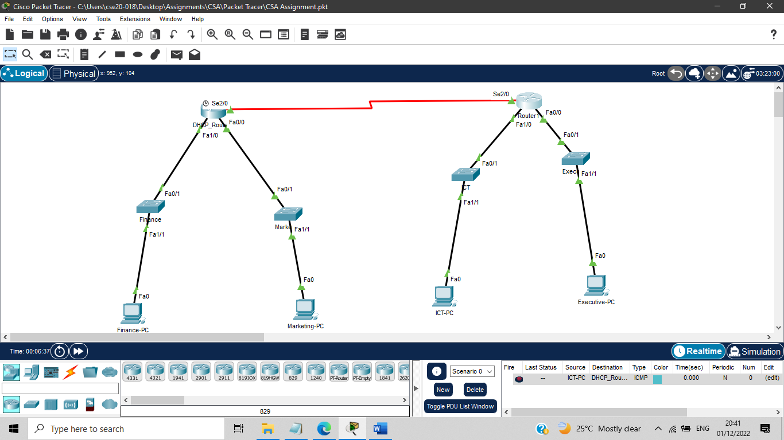

**Reference List**

-Ahmadi, H. (2017) ‘Defining and surveying Wireless Link Virtualization and Wireless Network Virtualization’, *IEE Communications Survey & Tutorials*, 19(3), pp. 1603–1627. doi:10.1109/COMST.2017.2704899

-Soofi,A.(2014) ‘Review on Data Security in Cloud Computing’ , International Journal of Computer Application, 94(5), pp.0975-8887.

-Chaudhary, A. (2017). 'Study Of Internet-Of-Things Messaging protocols used for exchanging Data with External Sources', *2017 IEE 14th International Conference on Mobile Ad Hoc and Sensor Systems(Mass),* Orlando,FL,USA, 22-25 October**.** Doi:10.1109/MASS.2017.85

-Ibnouf, I (2015) ‘Bandwidth Management On Cloud Computing Network’, IQSR Journal of Computer Engineering,17(2),pp.18-21. DOI:10.9790/0661-17221821